Fatima L154328

Aiza Zaheer L164363

Ayesha Ijaz L164101

Areesha Iftikhar L166320

ASSIGNMENT 1

REPORT

Oracle JD Edwards:

# **1.Introduction and History:**

Oracle JD Edwards was an enterprise resource planning that was founded in 1977 by Jack Thompson, C.T.P Hintze, Dan Gregory and C. Edward McVaney and hence the company was named as JD Edwards abbreviated as JDE.

JDE was purchased by PeopleSoft, Inc in 2003. But Oracle in 2005 purchased it again and Oracle continues to sell and support EnterpriseOne. JD Edwards EnterpriseOne was mostly used by small and medium-sized enterprises. It also caters the needs of manufacturing companies well. JD Edwards EnterpriseOne contains more than 80 separate [application](https://searchsoftwarequality.techtarget.com/definition/application) modules designed to support a wide range of business processes. The suite includes supply chain management ([SCM](https://searcherp.techtarget.com/definition/supply-chain-management-SCM)) software as well as applications for [financial management](https://searcherp.techtarget.com/definition/financial-management-system), [project management](https://searchcio.techtarget.com/definition/project-management), [enterprise asset management](https://searcherp.techtarget.com/definition/enterprise-asset-management-EAM), [order management](https://searcherp.techtarget.com/definition/order-management), [manufacturing operation management](https://searcherp.techtarget.com/definition/Manufacturing-operation-management-MOM) and operational reporting

# **2.Market Strategy and Strategic Direction:**

## **Market share and strategy:**

Oracle total ERP market share is 12% (calculated by iDataLabs) out of which half (5.21%) is JD Edwards EnterpriseOne. There are almost 9,142 companies using JD Edwards.

* **Future Market Strategy:**
* Additional mobile barcode scanning enhancements
* Mobile watchlists
* Mobile time entry
* Single sign-on
* **Overall Strengths:**

Oracle was ranked first in ERP ranking (by IT Central Station) while JD Edwards E1 ranks 2nd in ERP Cloud and 3rd in general ERP.

# **3.Product Offering and Integration:**

* **Overall ERP Product Line:**

Product offering and integration includes over eighty application modules. It includes special product for manufacturing companies like wingate electric. Products offered are:

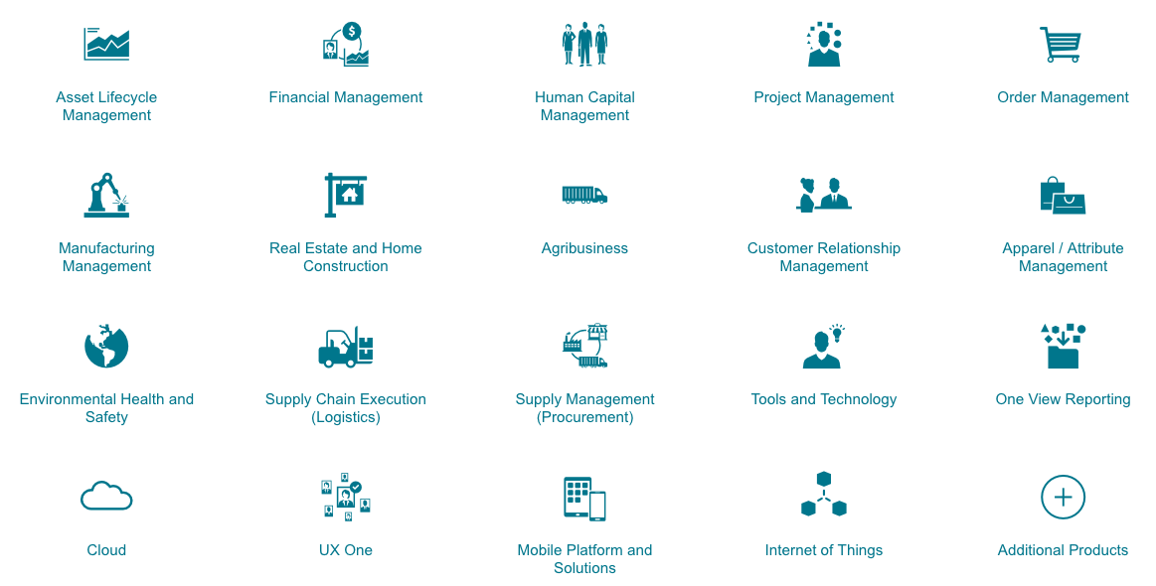

* **Module Integration Strategy:**

The JD Edwards SOA-based integrations consist of a broad set of tools for building application integrations. These tools enable customers to build integrations or business interfaces as needed. » Business Services

» Real-Time Events

» Oracle SOA Suite

#### **Integration through JD Edwards Business Interfaces:**

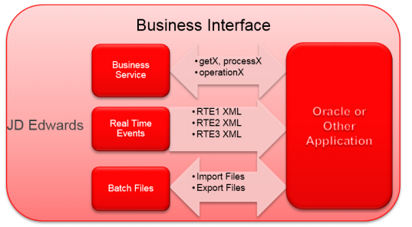

* **Modern Web Services and Mobile Application Development:**

The advent of enterprise mobility has opened the door for JD Edwards to develop another type of integration by delivering JD Edwards EnterpriseOne functionality on mobile devices. JD Edwards EnterpriseOne mobile applications have a truly native device look and feel and have access to all device capabilities.

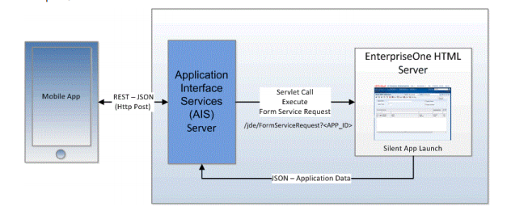

## **New Offerings:**

# JDE 9.2.4.3 offers latest products with enhanced and optimized features including digitial transformation in tools providing a way for debugging orchestration, providing direct access to business logic invoking a function, improving of navigation and page composers, and providing mobile application strategy for easing the use of user. New offerings also include Application enhancement including ERP optimization and enhanced features of modules .i.e. project costing, manufacturing, quality management, real estate etc.

## **Scalability:**

JD Enterprise One architecture is based on a flexible and scalable toolset built with open standards. It is very scalable and runs on multiple operating systems (Linux, AIX, Microsoft Windows, IBM I5OS), various databases ((Oracle, SQL, DB/2) and Virtual Servers (Oracle VM and VMware). It can easily grow and expand with your business.

# **4.Ability to Integrate:**

It provides a module namely JD Edwards EnterpriseOne Integrations and also provides custom modifications to each module for integrating finance module with sales using custom views and custom applications according to business needs. It also provides different integration platforms like BSSV server (SOAP – JAVA based APIS) and AIS Server (JSON over REST APIS) to integrate JDE with other systems. Additionally, JD Edwards also offers the following modules for integration: Business Services Server, Transaction Server, Connectors for point-to-point integration, Batch interfaces for bulk data transfer.

## **Integration with Production and Manufacturing modules:**

* Integrate manufacturing strategies to improve your competitiveness
* Manage all manufacturing modes with a single enterprise-wide system where all manufacturing processes share common inventory, material, planning, purchasing, and financial databases
* Enable quick transitions to different modes as you add or change product lines or tactics
* Simultaneously integrate all of your facilities regardless of which mode or modes they use
* UX One role-based landing pages for Plant Managers, Production Managers, and Production Schedulers provide at-a-glance alerts and analytics, along with easy navigation to take action

## **Integration with sales and marketing:**

The JD Edwards EnterpriseOne Sales Order Management system works with other financial, distribution, logistics, and manufacturing systems to ensure that customer demand is met. Supply and demand components must balance to ensure that demand is met. The key is integration and the proactive use of distribution and logistics information.

Systems that integrate with sales and marketing module:

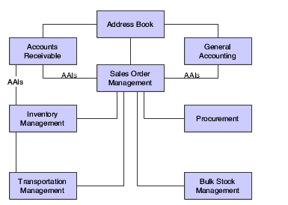

## **Integration with Human Resource Module:**

The Human Resources system integrates and track information with these JD Edwards EnterpriseOne systems:

* Address Book
* Human Capital Management Foundation
* Payroll
* General Accounting
* Accounts Payable
* Asset Lifecycle Management

## **Integration with web-based Application:**

The most important requirement is that it integrates easily with other complementary applications. In this regard JD Edwards EnterpriseOne does not take a one-size-fits-all approach. Rather, it offers several interoperability and integration patterns to ensure that system architects can apply the appropriate technology for an optimal solution to the requirements.

JD Edwards EnterpriseOne offers the following methods for interoperability and integration with other Oracle applications and third-party products:

* Business Services Server
* Transaction Server
* Connectors for point-to-point integration
* Batch interfaces for bulk data transfer

The Business Services Server provides interoperability between JD Edwards EnterpriseOne and other Oracle applications and third-party systems by natively producing and consuming web services. The business services server exposes business services as web services. A web service is a standardized way of integrating web-based applications, and in JD Edwards EnterpriseOne, web services are referred to as published business services. Business services provide operations that access the business logic in JD Edwards EnterpriseOne for many supported business transactions

# **5.Consulting Support:**

EnterpriseOne offers end-to-end support for all of JD Edwards E1 users.

* **Configuration Support**
  + Free official documentation available from Oracle
* **Technical Support**
  + Live Chat Facility from Oracle
  + Query Forums available
  + Support issues are available on jdelist.com
* **Consulting Support**
  + Consultancy Companies easily available worldwide
  + Over 40 years of experience in ERP industry implies availability of highly expert consultants for support
* **Consulting Cost**
  + Free Official Documentation
  + Free Chat with Oracle
  + Free Forums Support
  + Expert consulting cost varies according to the customization, enhancements, implementations and retrofit objects.

# **6.Training Availability:**

* **Training in Configuration:**

Official JDE manuals and documentation are present there in Oracle Docs for user guide and training purposes.

* **Technical Training:**

Also Training Support is available from jdelist.com for user training and various companies also provide paid JDE Technical Training. There are also JDE Training and Certification courses Available form Oracle University providing online classes as well as in-class courses for training purposes.

# **7.Fit with Current Business Processes:**

### **Sales and Order Processing processes:**

Description of Figure 1-1 follows

The sales order business process lets you effectively manage the order process and capture important business data for analysis. You must be able to effectively manage the process from the time a customer service representative takes an order to the time you receive payment from the customer.

**Enter Sales Order:**Order entry enables you to record information about your customers and the items that they order. When you enter an order, the system automatically enters pertinent information that exists for the customer, item, preference, and pricing records. Sales order processing begins as soon as you complete this step.

**Print Pick Slip:**After entering the sales order, you can print pick slips to authorize your warehouse personnel to pull the merchandise from inventory to fill the quantities and prepare the order for shipping. This step is optional.

**Confirm Shipment:**

You confirm that all of the items on the sales order have been correctly picked from the warehouse and packaged appropriately for shipping.

**Print Invoice:**

After processing a sales order through shipment confirmation, you print and send an invoice to the customer for the goods.

**Update/Post Sales:**

At the end of the day, you update sales information to maintain current and accurate records in:

* Accounts receivable.
* Inventory on-hand balances.
* Sales and commissions information.
* Pricing.

### **Financial Accounting Processing Modules:**

An accounts department plays an important role in managing the cash flow of a business; it is responsible for processing invoices for goods and services sold to customers of an organization and applying payments from these same customers. This module provides other different modules including:

* **Accounts Payable (A/P):**
  + Select the most efficient method with multiple voucher entry options.
  + Negotiate more favorable supplier contracts
  + Prioritize vouchers with workflow-driven payment processing
  + Establish prompt efficient invoice processing
  + Gain immediate accrual recognition with voucher invoice logging
  + Handle multicurrency and multiple language needs
  + Use the UX One Accounts Payable Manager role to obtain more discounts by ensuring prompt payment, analyze invoice processing and disbursements to support the company’s cash management strategy, and reduce the cost of invoice processing by increasing the Accounts Payable team efficiency.
* **Accounts Receivable (A/R):**
  + Tailor workflow to your business processes
  + See when and how customers are paying, and the discounts they are taking advantage
  + Handle multicurrency processing and international tax management
  + Define collections criteria using a combination of variables
  + Simplify handling of nonstandard customer deductions
  + Use the UX One Accounts Receivable Manager role to increase cash flow by decreasing the processing time with real-time alerts, analyze receipt trends to facilitate faster payment by customers, and foster strong customer relationship by monitoring and addressing their payment issues.
  + Use the UX One Collection Manager role to reduce collection time with real-time alerts, analyze collection data to design effective collection procedures, and improve efficiency of collections through effective management of delinquent customers.
  + Use the UX One Credit Manager role for efficient credit reviews with timely alerts, to monitor and enhance the credit granting process by analyzing historical trends, and enhance customer satisfaction with faster credit approval process.
* **General Ledger (G/L):**
  + Access consolidated financial information online, any time, across multiple currencies and languages
  + Accommodate country-specific practices, reporting requirements, and regulations
  + Organize your financial operations through companies, business units, or any other type of grouping, with the flexibility to change reporting structure as needed
  + See originating transactions while viewing the account balance online
  + Strengthen internal control procedures and identify data inconsistencies
  + Integrate seamlessly with all JD Edwards EnterpriseOne applications
  + Use the UX One General Accounting Manager role to ensure accurate account transactions with timely alerts, analyze journal entries to support the company's allocation strategy, and reduce general accounting expense per employee by increasing team efficiency

# **8.Reporting Applications:**

JDE EnterpriseOne One View Reporting offers Real-time operational reporting solution, intuitive interface empowers users to access and personalize transactional data into lists, charts, graphs, and tables and all financial, accounting, orders, HR and inventory modules support OneView Reporting.

## **Availability of Tools for Database Querying and Reporting:**

## **DB2 web-query for i:**

* This product provides several basic tools for building reports and business intelligence applications. Modules are as follows:
* Base modules provide foundation for DB2 web query including reporting server and web base authoring tools. A query400 function allows you to take query/400 definitions and transform them using web-based report assistant tool.
* Active Technologies can combine results of queries and create HTML reports that can be made available to users.
* The DB2 Web Query Developer Workbench is an open and intuitive environment that you can use for rapid development of more customized reports and metadata.

## **Web-Based Reporting Capability:**

### **Launching Application and Reports:**

JD Edwards provides a variety of applications, reports, and other objects. Typically, you access these objects from the EnterpriseOne Menu.

### **Viewing the data in Tables and Business Views:**

If you want to view the data in tables and business views, you can use Data Browser. This tool enables you to verify the existence of data in a table or business view, as well as to determine the table or business view structure.

### **Recover Data:**

It provides following functions:

* + Retrieve all records from the database.
  + Voluntarily save data.
  + Retrieve data.
  + View data.

**Working with Tasks, User Options and Calendar:**

It describes how to:

* Filter tasks by role.
* Use task profiles.
* Work with user options.
* Access the calendar.

# **9.Cost:**

## **License subscription cost:**

JDE EnterpriseOne offers moderate costs i.e. The product is offered through **a** subscription-based licensing model that starts at $999/month for base access along with $99/user/month for additional users. Additional users can be added at any time by purchasing additional access. The base price does not include fees associated with services such as installation, customization or training. However, the upfront cost for maintenance and upgrades is included in the base price.  
The software contract may be renewed annually or over longer durations.

## **Maintenance Cost:**

Maintenance is included in the monthly base subscription cost.  
NetSuite Support is provided in silver, gold or platinum packages. This support is required for users who purchase licenses directly from the vendor.

## **Installation/Implementation Cost:**

Installation and implementation costs are not included in the base subscription price.  
Implementation services are provided through partner/reseller channels, and prices vary based on requested services and on the solution provider that your company uses.

## **Customization Cost:**

Customization is an additional cost and varies based on the functional requirements or modules added such as financial management, order management, production management, supply chain management and human capital management.

# **10. User Friendliness:**

* **Highly interactive interface** that leverages Dynamic HTML and provides immediate feedback to the user. Form Personalization that lets you perform operations like hide/show, move, rename, resize, and reposition the controls in a form so that relevant information can be utilized efficiently. One of the user friendliness features includes Mobile computing .i.e. it is available on the Apple iPad, and JD Edwards-specific gestures are the simple way to complete tasks anywhere.
* **Training in Configuration:**

Official JDE manuals and documentation are present there in Oracle Docs for user guide and training purposes.

* **Technical Training:**

Also Training Support is available from jdelist.com for user training and various companies also provide paid JDE Technical Training. There are also JDE Training and Certification courses Available form Oracle University providing online classes as well as in-class courses for training purposes.

**SAP Business One**

**Introduction:**

SAP Business One is business management software ([ERP](https://en.wikipedia.org/wiki/Enterprise_resource_planning)) designed for [small and medium-sized enterprises](https://en.wikipedia.org/wiki/Small_and_medium-sized_enterprises), sold by the German company [SAP SE](https://en.wikipedia.org/wiki/SAP_SE). As an [ERP solution](https://en.wikipedia.org/wiki/Enterprise_resource_planning), it aims to automate key business functions in financials, operations, and human resources.

SAP Business One is a single, integrated solution that provides clear visibility into your entire business and complete control over every aspect of your operation. It captures all critical business information for immediate access and use companywide. Unlike accounting packages and spreadsheets, it delivers what you need to manage your key business areas. Because every business is different, is designed with flexibility in mind. Whether it is deployed on premise or in the cloud, you can access at any time, anywhere via any mobile device. And because it runs on both the SAP HANA and Microsoft SQL server platforms, you can choose the one that suits your business best.

1. **Corporate History, Experience and Profile:**

* SAP Business One was initially launched in Israel in 1996 under the name "Menahel" ("manager") or "TopManage", for countries out of Israel. The company was founded by Reuven Agassi (CEO) and Gadi Shamia (VP of sales, marketing and product). In March 2002, SAP purchased TopManage Financial Systems and branded their system as SAP Business One.
* Developed by SAP
* Released in April 2002
* Suitable for small to medium size companies
* SAP Business One how one can make life simpler.
* SAP: 29+ Years in business
* SAP business One is an ERP software for small businesses. It increase control over your small business with software designed to grow with you. Streamline key processes, gain greater insight into your business, and make decisions based on real-time information – so you can drive profitable growth.

1. **Market Strategy and Strategic Direction:**

**Market Strategy:**

* Of all the companies that are using SAP Business One,33% are small (<50 employees), 43% are medium-sized and 24% are large (>1000 employees).
* Small business Strategy

**Market Share:**

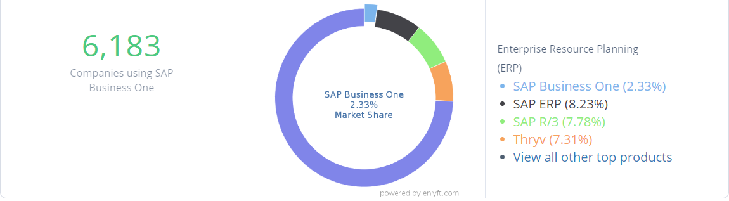

**Future Strategy:**

**Planned Innovation**

**Core**

* Web client introduction
* Business process automation
* Machine learning

**Globalization**

* Advanced localization platform (electronic files and documents automation); Arabic and Ukraine localizations
* Electronic documents as a service integration
* Statutory reporting framework integration
* Personal data protection (EU GDPR)

**Analytics**

* SAP HANA 2.0 support and features

**Mobile**

* Service app; offline capabilities for sales app

**Extensibility**

* Grow vertical solution base
* Internet of Things (IoT); integration editions for single-board computers and cloud with built-in multitenancy
* Enhanced marketplace

**Cloud**

* Various hosting options
* Improvements in stability, security, and high availability
* Substantial management of users, software, and tenants

**Product Direction:**

**Core**

* Web client extended functionality
* Optimized scalability/performance
* Machine learning

**Globalization**

* Expansion to new markets/regionsElectronic documents as a service integration
* Integrations to electronic fiscal services
* Brexit requirements

**Analytics**

* Insight to action (data mining)
* Predictive, pervasive, and scalable
* Built-in content

**Mobile**

* Grow solution base, extension platform

**Extensibility**

* Business network integration
* Service layer evolving toward extension platform; semantic layer

**Cloud**

* Hybrid deployment
* Simplified cloud tools
* Extension repository

*“SAP Business One is a centerpiece of SAP’s strategy, and therefore we are strategically investing. SAP Business One is absolutely strategic, we are fully committed to the next 10 or 20 years. We are making SAP Business One fit for the next generation, for the next decade, by enabling the digital services so the digital transformation can be done with SAP Business One.”*

***Rainer Zinow, SVP, Head of SAP Mid Market Product Management, SAP SE***

***December 2019***

**Overall Strengths**

### Run and maintain your ERP software affordably: Lower the cost of managing your business, from financials, purchasing, inventory, sales, and customer relationships to project management, operations, and HR.

### Handle all your department needs with one solution:Gain clear visibility and complete control over every aspect of your small business. Capture critical information for immediate access and use it company-wide.

### Power your business growth with keen insight: Secure the achievement of big dreams and big goals. Get a single view of your business in an instant with a flexible, modular, powerful, and simple interface.

### Affordable:Low total cost of ownership

### 28 languages, 44 localized version and multi-currency support

### 800 local partners and implemented in 150+ companies.

* Frictionless and positive customer experience through integrated e-commerce, Customer Relationship Management, and mobile sales management.
* Better warehouse and logistics management through EDI, a wireless warehouse, more precise purchasing, and shipping container optimisation.
* Streamlined financial management through Accounts Payable automation, and expense management automation.

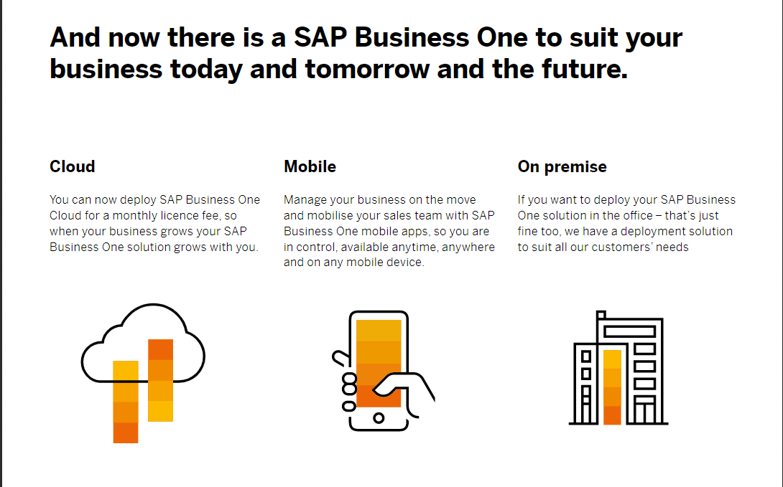

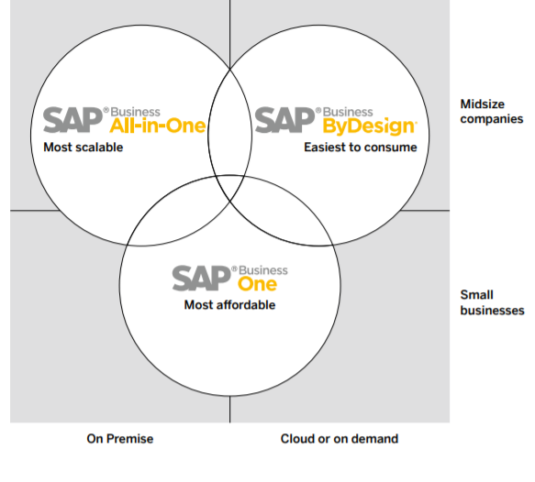

1. **Product Offerings,Integration, and Scalability**

**Overall ERP Product line**

## **SAP S/4HANA**

Improve decision making and increase productivity with a digital core that supports all your mission-critical business processes. Built on the SAP HANA platform, the SAP S/4HANA Enterprise Management solution is designed with the SAP Fiori user experience and delivered in the cloud and on premise.

## **SAP Cloud Platform**

Build and deploy apps quickly with our cloud platform-as-a-service (PaaS). With SAP Cloud Platform, you can deliver secure business apps that integrate and optimize your IT landscape, drive agility, and accelerate digital transformation – in weeks, instead of years.

### **SAP HANA**

Accelerate business processes, deliver more business intelligence, and simplify your IT environment with our in-memory data platform that provides the foundation for all your data needs.

### **Concur Expense**

Integrate travel spend, ERP, accounting, and card data into a single, cloud-based and mobile system that manages the entire expense process – from spend requests to reconciliation.

### **SAP Ariba Strategic Sourcing Suite**

Manage sourcing and suppliers across all spend categories with a single closed-loop, source-to-contract suite of solutions that handles the advanced requirements of direct materials sourcing.

### **SAP BusinessObjects Business Intelligence Suite**

Increase responsiveness, reduce IT costs and workload, and drive better decision making by providing easy, self-service access to insights on a unified platform for data and analytics.

### **SAP Commerce Cloud**

Deliver exceptional, seamless customer experiences by integrating all digital and physical customer touchpoints – including online, mobile, call center, and social media – onto a single platform.

### **SAP SuccessFactors Employee Central**

Transform the work experience with a cloud-based, multilingual solution that serves as a “system of record” for people- and HR-related data, as well as a platform for streamlining core HR processes.

**Integration And Scalability:**

* Integration with the SAP HANA platform
* SAP Business One is potentially a good choice for companies that do business globally because the software supports multiple currencies.
* **Scalability**: The SAP Business One technology can support 2 - 100+ users making it a whole business life proposition.
* Available computing resources can effortlessly scale up or down according to business requirements.
* SAP B1 easily integrates with existing applications, such as Microsoft Office, Google Apps and Magento.

**Module Integration Strategy:**

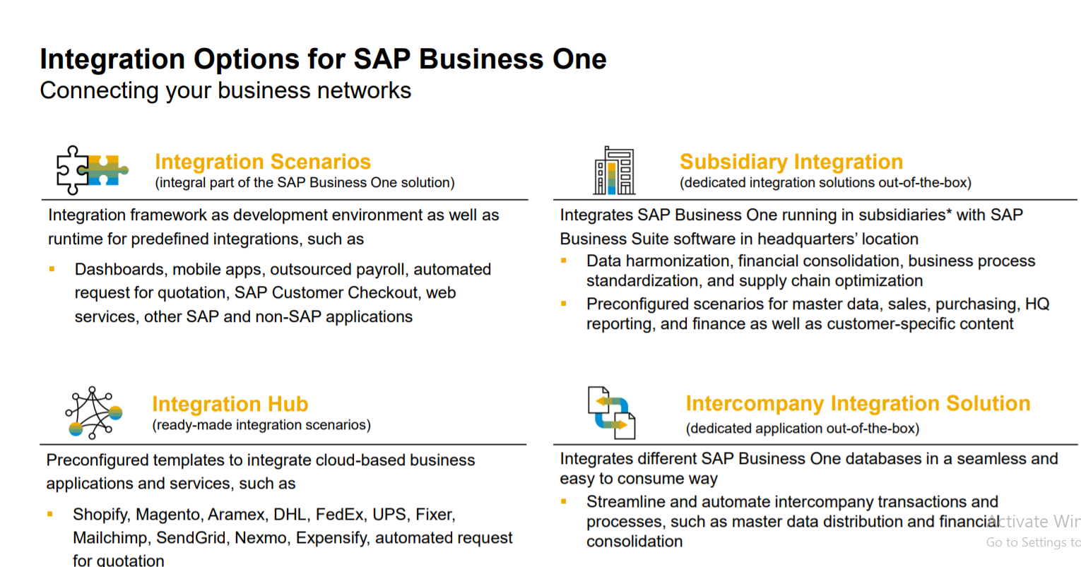

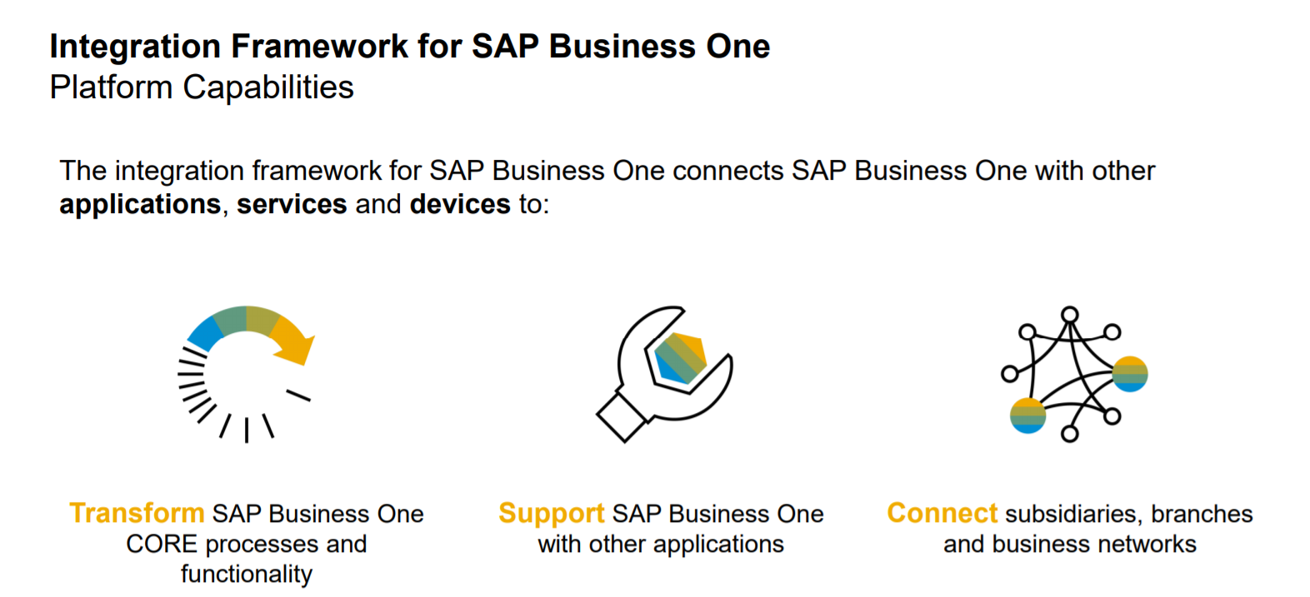

**Web Based Application Strategy:**

* Build intuitive business applications for mobile, web and conversational channels
* Connect people, processes, data, and devices everywhere
* Rapidly develop robust and scalable cloud-native applications
* The SAP Business One strategy has always been about providing a core application with a broad functional scope  and allowing the development of additional solutions that extend the functionality to meet a specific customer need or a specific industry requirement.

**New Offerings:**

* Most recent stable release 9.3
* New features include:
  + Production enhancements
  + Project Management Enhancements
  + RMA features
  + Usability Enhancements (CRM menu + user-preference unification)

1. **Consulting Support :**

SAP Business One consulting services assist clients with configuring and deploying this program.

**Support for configuration of Application modules**: Access specific information and documentation that can help you upgrade your SAP Business Suite core applications including SAP NetWeaver and SAP Business Objects.

**Availability of consulting support :**

* + 24x7 support for critical issues
  + SAP delivers a superior standard support service to ensure continuity of your business operations.
  + Single access point for support tasks via the support launchpad for SAP Business One
  + Automation and proactive support tools such as remote support platform for SAP Business One
  + Software upgrades and updates

**Cost of Consulting Support**:

Free of cost consulting support provided by sap business one

## **Technical Support for system Implementation:**

* **Support Launchpad for SAP Business One**: Report an incident, search for notes, request license keys, and maintain your users and systems, with a seamless, consolidated, and simple support experience.
* **SAP Help Portal** : Visit the SAP Help Portal to stay up to date on the latest information on installation, upgrades, and product availability.
* **Remote support platform for SAP Business One**: Protect your installation of SAP Business One by monitoring the health and integrity of your customer databases with proactive, effective support.
* **Maintenance and Release**: Get the enhancements you need to gain the full potential of your investment in SAP Business One during major and minor releases.
* **Upgrades and Patches:** Receive new versions of SAP Business One, as well as patches, for free when you have a valid maintenance agreement with SAP.

**Support for SAP business One Customers:**

* SAP Business One is sold, implemented, and supported by our partner network. The close interaction and collaboration between SAP and our channel partners allows best-in-class support.
* Use the support launchpad for SAP Business One to request support from your partner or to request a license key.

1. **Training Availability**

**Training in configuration:**

* Free SAP Training, named as OpenSAP
* Take advantage of free training from openSAP, our online learning platform. To sign up for courses, all you need is a valid e-mail address
* Training will empower your SAP end users from developers to marketers with training and enablement solutions for SAP Business One.
* SAP Global Certification
* Validate your expertise using SAP solutions and ensure you meet the requirements for new roles and responsibilities by completing SAP certifications.
* SAP Training Courses
* Browse our Web shop to discover the latest course availability, find training locations near you, search course codes, or focus on a specific training path.
* SAP learning hub will help to Gain free, instant access to online learning content for SAP Business One through the SAP Business One academy.

### Learn the way you want, anytime and anywhere: Find presentations, simulations, demos, case studies, and quizzes to test your knowledge. Whatever your preferred method of learning, you can access it with ease and speed.

### Deliver learning content in a variety of languages:Connect your workforce with training content available in nine different languages: English, German, Spanish, Brazilian Portuguese, Russian, French, Korean, Japanese, and Chinese.

### Experience a clear path to certification: Get the training you need to fully prepare for the certification exam on SAP Business One. Relevant topics are highlighted, so you know what you need to know before taking the exam.

### You can access SAP Business One training on the SAP Learning Hub. Available course materials include presentations, demonstrations and simulations on a wide range of SAP Business One topics. The training is available to public by registering

### Technical Training:

### 

### 

### 

### **Fit with Current Business Processes**

* **Fit with sales and order Processing processes**
* Oversee the entire sales process and customer lifecycle more efficiently – from initial contact to final sale, after-sales service, and support.
* Track sales opportunities from start to finish.
* Create, manage and analyse marketing campaigns.
* Gain insights from customer master data
* Manage warranty and service contracts more efficiently.
* Mobilize your sales team with the sales app
* Perform intelligent reporting and analytics.
* Efficiently manage the entire sales process and customer lifecycle.
* **Fit with financial accounting processes**
* Improve margins, reduce errors, and drive more profitable decision-making with a complete set of tools for streamlined financial operations.
* Manage Cash flow, track assets and control budgets.
* Accelerate month-end close and enhance compliance.
* Business audit and planning with better insights.
* Streamline reconciliations, bank statements and payments
* End to end control of your company’s fixed asset.
* Capture all your financial information in a single, scalable system.
* **Fit with Managerial Accounting Processes**

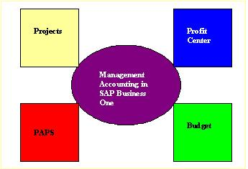

### **Reporting Applications**

### Current Reporting capabilities:

* **Report creation and customization**– Access data from multiple sources, create new  reports, or customize existing ones in a variety of layouts with minimal IT overhead
* **Report viewing**– Enable powerful visualizations and analytics and interactivity using integrated tools such as Adobe Flash and Adobe Flex
* **Publishing and distribution**– Export reports to electronic formats that best fit your   business needs, and deliver them either over the Web or embedded in other applications, including portals, while preserving security
* Empower your employees to make smart, confident decisions faster by capturing all critical information and making it instantly available company-wide.
* Design intuitive, interactive dashboards and reports that answer your most-pressing questions.
* Access information faster and evaluate it with powerful analytics in real time.

**Benefits**:

* **Faster and better decision making**–  thanks to timely and accurate reports based on  critical company data across financials, sales, customers, inventory, service, production, and operations
* **Cost savings**– resulting from reduction in time and effort required to generate reports and reduced dependence on IT
* **Improved access** – to critical business information  any way people require it and at any time

**Availability of Tools for Database Query and Reporting**

SAP Business One provides two different query tools that you can access from the SAP Business One client:

* Query Wizard
* Query Generator

Both tools assist you in creating queries using the structured query language (SQL). SQL is a standardized set of commands for accessing and formatting data in relational databases. Although both tools produce the same results in the end, you should understand their differences.

**Reporting tools available with the SAP Business One System are:**

* Crystal **Reports**.
* Excel Reporter.
* Query Designer.
* Optional - HANA's game changing in-memory solution.

### Web Based Reporting Capability:

### 

1. **User Friendliness**

* Provide information to understand how to implement, manage, and configure SAP Business One.
* Provide structured visual guides designed to help you navigate the path to becoming fully competent with high-priority SAP solutions.
* Interactive User Interface

**Availability of Tutorials:**

### 

### Availability of Application module Documentation:

### 

### 

### Technical Documentation:

### 

1. **Cost**

* SAP Business One costs include implementation costs, licensing costs, and SAP Business One costs for maintenance and training of key and end users.
* Cost for SAP training = $5800
* The subscription pricing for the professional license is $108 dollars per user per month, with no additional annual maintenance fee the price of SAP Business One is $3,213/user for a Professional License and $1,666/user for a Limited License
* The perpetual license is $3,213 per named user with an additional maintenance fee due each year.
* SAP business One implementation cost range from $35k to $150k.

### **Licensing via a subscription model, SAP Business One Pricing starts around $150-$170 per user, per month which also includes fees to host the application.**

### ERP Modules Cost:

### **Finance: General ledger, purchasing, accounts payable, accounts receivable, BAS, fixed assets, banking, budgeting, financial reporting: 15 days implementation = $22,500**

### **Distribution: Inventory management, purchase planning, forecasting, purchase orders, goods receipting. CRM – activities and sales opportunities: 30 days implementation = $45000**

### **Manufacturing: Finance, distribution, manufacturing – Works orders, MRP, BOM’s, production resource planning. CRM: 40 days implementation = $60,000**

### Job Costing: **Finance, project costing / services – job costing type project services management, billing and reporting, CRM: 40 days implementation = $60,000**

1. **Ability to Integrate:**

**Integration with finance and accounting module:**

Integration with finance and accounting modules will provide these additional features

* Chart of accounts
* Journal entries
* Posting templates
* Recurring postings
* Financial reports
* Budget management
* Cost accounting
* Incoming payments
* Outgoing payments
* Payment run
* Bank statement processing
* Checks & credit cards
* Deferred payments
* Account reconciliation
* DATEV / ELSTER (DE)
* Fixed Assets
* SEPA

**Integration with production and manufacturing module:**

Integration with production and manufacturing modules will provide these additional features

* Bills of material
* Item Sets
* Production orders
* Goods issues
* Goods receipts
* Production Dashboards
* GL Account Determination
* Life Cycle Management
* Item cost calculation
* Forecasts
* MRP
* Make to order
* Order recommendations
* Production Routing

**Integration with sales and marketing module:**

Integration with sales and marketing modules will provide these additional features

* Opportunity and pipeline Mgmt.
* CRM
* Campaign Mgmt.
* Blanket agreements
* Quotations
* Sales orders
* Deliveries & Returns
* Invoices
* Dunning & Customer Mgmt.
* Gross profit calculation

**Integration with Human Resource module:**

Integration with human resource modules will provide these additional features

* Internal project handling
* Employee master data
* Time sheet entries
* Resource master data
* Resource capacity planning
* Gantt chart capacity viewing

**Integration with web-based Application:**

* Is based on SAP Fiori design principles encapsulating SAP Business One core processes and business logic
* Focuses on creation, processing, and updating of Sales Quotations, Sales Orders, A/R Deliveries, and A/R Invoices
* Supports creation and update of items, business partners, and activities
* Provides sophisticated analytic charting capabilities
* Can be launched in either a desktop computer or tablet; or directly from the SAP Business One desktop application

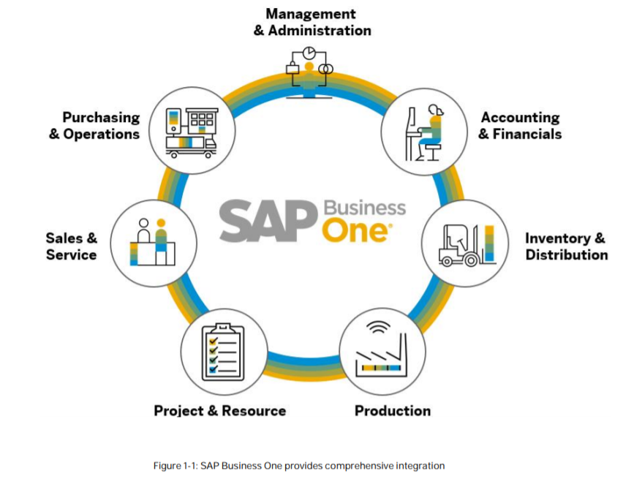

**SYSPRO**

**Introduction:**

**SYSPRO is an Enterprise Resource Planning (ERP)** system providing integrated business software including accounting, manufacturing and distribution operations across a wide variety of industries. It helps to gain full view of all business activities, including **financial**, **warehouse** and **inventory management**, across the **supply chain** and **business operations**. It can be deployed in the cloud, on premise, or accessed via any mobile device.

Specializing in the [**Manufacturing**](https://www.syspro.com/industries/manufacturing-software/) and [**Distribution**](https://www.syspro.com/industries/distribution-software/) sectors, SYSPRO ERP provides the solutions, processes and tools to assist one to **manage your data and gain insights** into a business. It provides the ability to innovate based on market needs and to focus on faster time-to-value, helps to achieve that last-mile functionality to promote the success of a business.

1. **Corporate History, Experience, and Corporate Profile**
2. **Overall History:**

SYSPRO was founded in **1978** by Phil Duff to provide industry based ERP solutions. It has since established an ongoing presence in the mid-sized enterprise market. In 2014, it reports a customer base of over **15,000** licensed companies in more than **60** countries worldwide. SYSPRO was listed in the Top **10** ERP Systems for 2017.

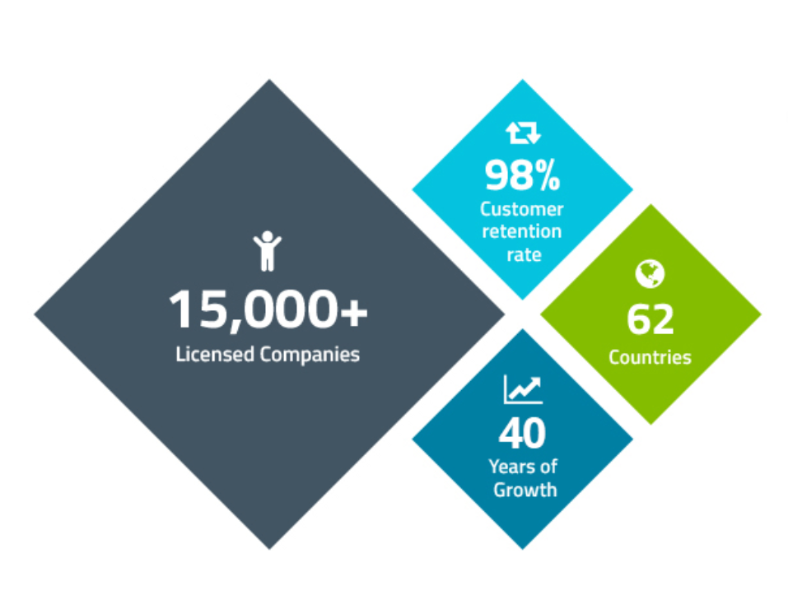

1. **Number of Years in Industry:**

SYSPRO has an experience of **42** years in industry providing best possible services that they can provide.

1. **Position in the industry:**

SYSPRO has **43rd** category position in the industry when it is compared with other competitors.

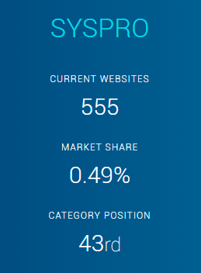

1. **Market Strategy and Strategic Direction:**
2. **Market Share:**

SYSPRO has market share of less than **0.49%**.

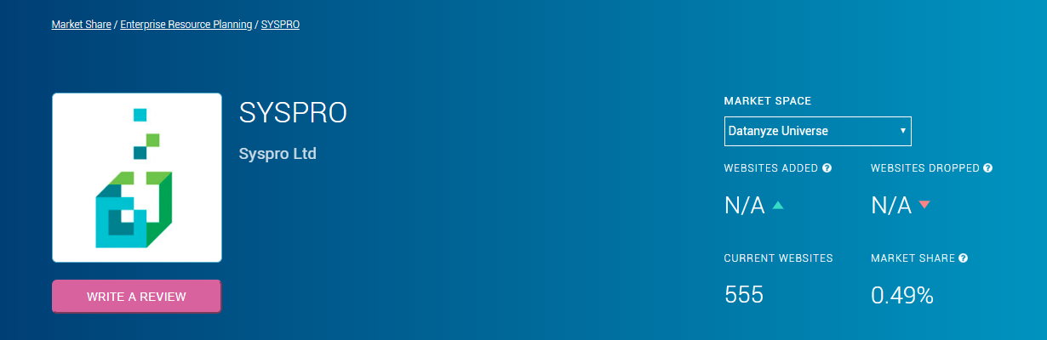

1. **Market Strategy:**

Technology has become the vehicle to allow business to expand globally, regardless of size or industry. It continues to become easier to market and supply goods or services around the globe. Social, mobile, cloud and access to information are transforming user behavior. Content needs to be more directed, integrated and personalized. The User’s experience (UI) has become a priority as has reducing costs and providing extensibility.

1. **Future Market Strategy:**

The future market strategies for SYSPRO include focusing on the following points:

* Bill of Materials (BOM) Editing
* Routings Editing
* Interface to Estimations, BOMs and WIP
* Graphical Scheduling, planning and SFDC

1. **Overall Strengths:**

The use of SYSPRO has been found mostly in the United States, in the machinery industry. It is mostly used by the companies having **50-200** employees and with **10M-50M** dollars revenue.

**SYSPRO ERP** is designed around the needs of manufacturers and distributors and provides the tools to provide visibility and drive business behavior across the organization – improving business performance.

* It helps us get **real-time view** of the company’s key business
* Drives business behavior by providing the users with **actionable business-critical insights** for quicker analysis and decision making.
* Upgrade business performance by a **productive workforce** that is made to act quickly and proactively
* Motivates users to **meet goals and targets**, and increase responsiveness, lead times and overall productivity
* **Improve profitability and minimize risk** with increased visibility into your company’s financial health

**Profile:**

* SYSPRO is a powerful enterprise resource planning platform designed to help businesses, specifically in the manufacturing sector, integrate, synchronize and control the manufacturing process.
* They provide seamless tools for integrating business processes over corporations.
* Flexible deployment means we have the option for both **On-Premise or On-Cloud**
* Provides option to customize the interface according to your requirements
* you can depend on it for the long term as it can easily adapt to meet the growing needs and changing operations of your expanding business.

1. **Product Offerings, Integration, and Scalability:**
2. **Overall ERP Product Line:**

The overall ERP product lines include:

* Cloud
* On-Premise
* Mobile App
* Web-based.

Our product is always being developed to simplify complex technologies, business processes and external conditions to optimize our customer’s business. SYSPRO’s four product pillars are based on a foundation of being simple to use, intuitive, engaging and always available.

1. Always on.
2. System of Engagement.
3. Future Proof Your ERP Investment.
4. Optimize Operations.

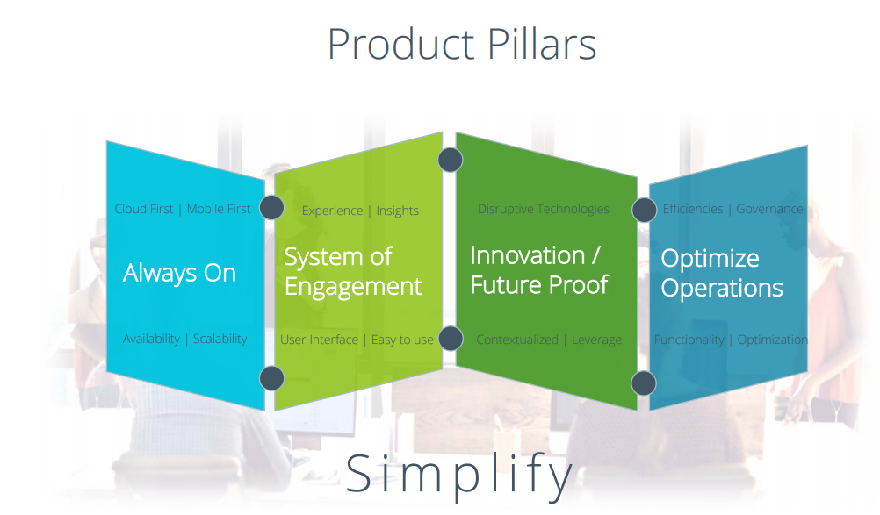

1. **Module Integration Strategy:**

The SYSPRO Integration Framework enables you to extend your [**ERP applications**](https://www.syspro.com/product/syspro-erp/applications/erp-applications/) to work with other data systems both within and outside of the enterprise. The result is improved collaboration, speed, efficiency, as well as easier access to information across the business.

1. **Web Based Application Strategy:**

SYSPRO unveiled its candidate program, web-based version of **SYSPRO 8** in the fourth quarter of 2017 to proactively enhance their manufacturing and distribution solution for business owners. SYSPRO 8 is a dual user-interface offering, allowing for companies to selectively deploy either the Windows client or the web-based solution at their discretion. The reason for this is that it provides business continuity and ensures a smooth transition for users. This dual offering will provide significant value and flexibility to organizations, deploying the rich-UI (user interface) to data capture intensive users and the web-UI to users who prefer a web-based engagement with SYSPRO.

1. **New Offerings:**

CRM for SYSPRO is a feature-rich, enterprise-class solution that allows customers to strengthen relationships across the entire supply chain. The solution provides access on the go through mobile responsive forms or from a standard browser. Complete view of each relationship, including related ERP data from SYSPRO, is available in an easy-to-use format with customizable grids and views.

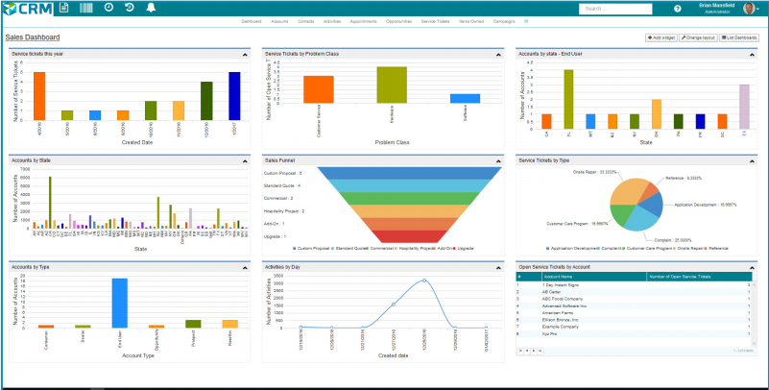

**CRM for SYSPRO**:

* Protect data from unauthorized access with a robust security model
* Define unlimited number of custom fields, grids, views, and forms by user or role
* Easily find data using extensive search and filtering capabilities including global, grid, view or column based lookups.
* Quick ROI with rapid implementation and training.
* Implement local or server based workflow processes to automate routine business requirements.
* Leverage social media with support for LinkedIn, Facebook, Google+ and others.
* Integrate with other systems with quick launch capability and extensive API call support.
* Save time with easy-to-use data conversion and migration tools.

1. **Consulting Support**
2. **Support for Configuration of Application Modules:**

SYSPRO’s mission is to deliver unparalleled [**support services**](https://www.syspro.com/erp-services/erp-support/) to our partners for the mutual business success of you and your customers.. Well-trained users are efficient, highly motivated and often discover new ways to save time and improve business processes by providing complete support for the configuration of the different application modules.

1. **Technical Support for System Implementation:**

**SYSPRO** offers global Helpdesk **Support** via telephone, email and fax. Our skilled **support** team will help resolve any **technical** problem, giving you a clear and simple solution. On-site **support** is ideal when implementing new features or new solutions, or for users who will be taking on new roles and tasks. When required we have a technical team available to assist you in adapting your SYSPRO ERP system to match your business model and its specific challenges. Because your business requirements evolve and change as your business grows and expands, all of our SYSPRO customizations are built to be both flexible and adaptable.  We provide technical help with:

* User Interface Customizations.
* Crystal Reports.
* Dashboards.
* Personalization.
* Customizations and Enhancements.
* System Integration.

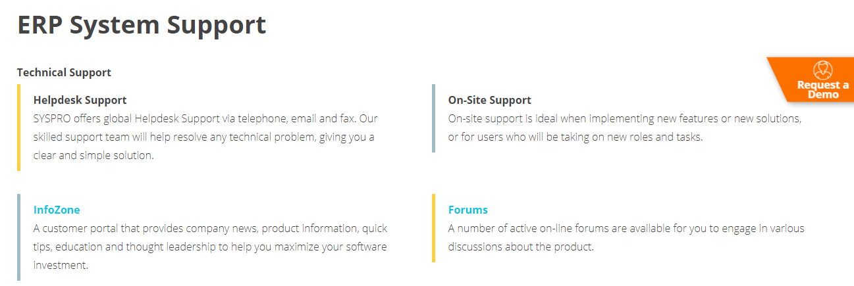

1. **Cost of Consulting Support:**

The consulting support provided at SYSPRO are cost free, ensuring the best possible services by keeping the cost as minimal as possible.

1. **Availability of Consulting Support:**

SYSPRO provides a list of ERP consultants who can be contacted with online and any kind of support can be acquired, thereby resolving an issue solved.

1. **Availability of Training**
2. **Training in Configuration:**

One of the most important aspects to consider when [**safeguarding your ERP investment**](https://www.syspro.com/ebook/syspro-safeguarding-your-erp-investment/) and ensuring user uptake, is the training and education of the people who use it. We strive to make the **ERP training** and learning experience for training in configuration.

1. **Technical Training:**

The **SYSPRO Learning Channel (SLC)** is a one-stop-shop for all your educational needs, ensuring that you have access to technical training material when you need it, where you need it.

Offering a range of different educational material formats, the SLC provides online access to a library of documents and videos, e-learning courses, and certifications via your desktop or mobile device.

So, no matter where you are, SYSPRO’s educational material is at your fingertips, offering you the following benefits:

* Learn how to use **SYSPRO** to be fully equipped and empowered to perform your day-to-day activities.
* Stay up-to-date with new capabilities and tools as they are made available
* Achieve your educational goals by monitoring your own progress, competing with others on the leaderboard and optionally obtaining a certification.

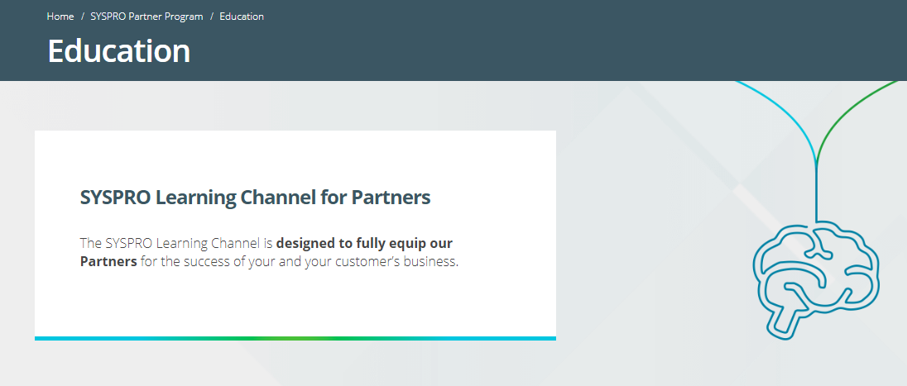

1. **Fit with Current Business Processes**
2. **Fit with Sales and Order Processing Processes:**

SYSPRO fits with the current sales and ordering processes to save manufacturers and distributors time in a significant part of the sales process: managing and fulfilling orders. These orders can come directly from end users or indirectly from OEMs, partners and other customers.

1. **Fit with Financial Accounting Processes (A/R, A/P, General Ledger):**

**SYSPRO fits General Ledger that provides** management of corporate performance, monitoring of ROI. Provides complete enterprise-wide financial recording, analysis and reporting from all aspects of the business.

**Financial management software** from SYSPRO delivers core financial and accounting functionality – but more than that, because it includes integrated manufacturing and operational capabilities, with SYSPRO you gain a true, complete picture of the factors that influence your company’s financial health, in real time.

There are **6** steps that can be taken to bring financial processing with SYSPRO ERP to a new level:

* Predict and Manage Cash Flow
* Simplify Quoting with Accurate Cost Forecasting
* Manage Sales Forecasts for Better Budgeting
* Streamline Everyday Accounting Transactions
* Speed Corporate Governance and Compliance Reporting
* Improve Enterprise Performance Management

1. **Fit with Managerial Accounting Processes:**

**SYSPRO** follows managerial accounting processes as it supports:

* Inventory Costing methods**.**
* Inventory Forecasting.
* Sales Analysis.
* Landed Cost Tracking.
* SYSPRO Financial Analysis.

1. **Reporting Applications**
2. **Current Reporting Capabilities:**

**SYSPRO Reporting** Services is the next-generation **reporting** system planned to replace all standard **reports** within the **SYSPRO** ERP business solution. **SYSPRO Reporting** Services ships with an impressive array of predefined **reports** that work 'out-of-the-box', enabling businesses to derive immediate benefit. However, its true power lies in the total flexibility it gives businesses to design custom reports to virtually any level of complexity, complete with tailored reporting options, preferences and layout features.

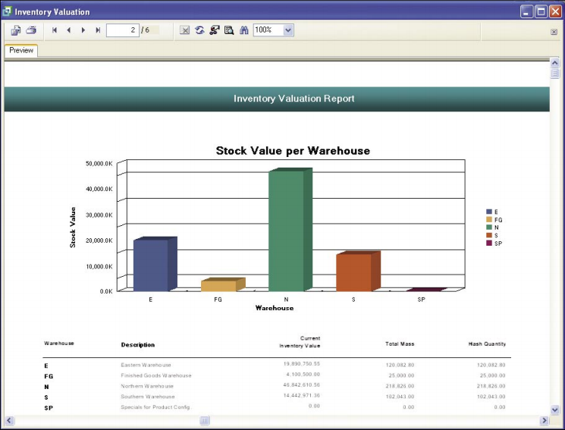

**Summary of benefits:**

**Cost savings:**

* + Report archiving facility reduces consumption of office stationery
  + External database driver licenses no longer required to access the SYSPRO database
  + External report designer services no longer required
  + Protect reports from changes in technology upgrades

**Productivity:**

* + Preview report content and layout
  + Run multiple reports simultaneously, in the background
  + Dynamically filter report contents
  + Schedule reports
  + Automated report completion notifications
  + Live report pages with interactive hyperlink features
  + Rapid retrieval of report history and archive access
  + Automatic translation of report headings into specific languages

**Business empowerment:**

* + Configure forms for report options and preferences
  + Customize report fields, layout and themes
  + Selective report sharing between users and companies
  + Protected access to information
  + Multi-format publishing
  + Alternative to Word Printing

1. **Availability of Tools for Database Query and Reporting:**

**SYSPRO** has adopted Microsoft SQL Server as its database and it is a cloud-based database management system that provides enterprise-strength data integrity, security, scalability, availability, and performance that can be accessed by all **popular querying and reporting tools**. Only by running SYSPRO on SQL Server can following of these requirements be fully satisfied:

* Data Integrity.
* Availability.
* Scalability.
* Self-tuning.
* Data accessibility.
* Data Retrieval.
* Data Maintenance.
* Data Customization.

1. **Web-based Reporting Capability:**

SYSPRO has not yet incorporated the web-based reporting capability.

1. **User Friendliness**

**SYSPRO** Harmony is a 21st century, **user**-**friendly** social media-type platform. It is embedded into **SYSPRO** ERP and designed to streamline business processes and improve communication channels, to create a productive and satisfying working environment.

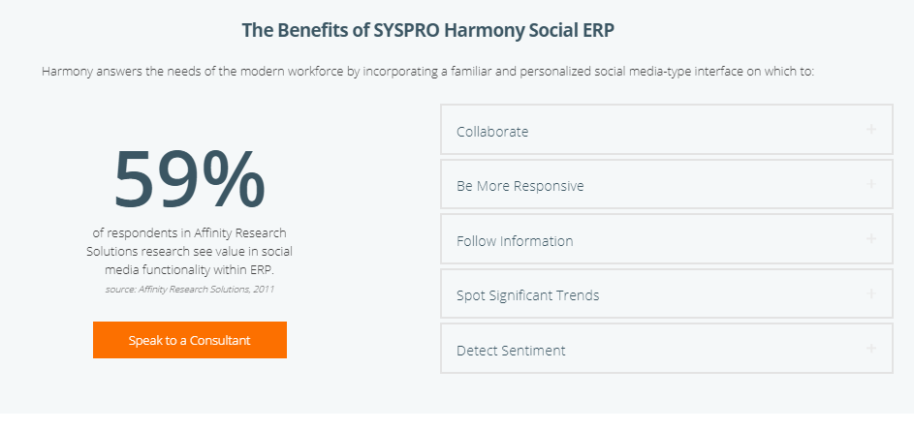

1. **Availability of Tutorials:**

The [**SYSPRO Learning Channel (SLC)**](http://corporate.slc.syspro.com/oltpublish/site/cms.do)ensures that you’ll have access to training material when you need it, where you need it. Our Open Learning Library – freely available to all SLC members – houses a vast collection of educational content, including:

* Training guides covering SYSPRO modules, features, roles, processes, enhancements
* Solutions
* Step-by-step “how-to” tutorials
* Feature demo videos
* Conceptual videos
* Recorded webinars

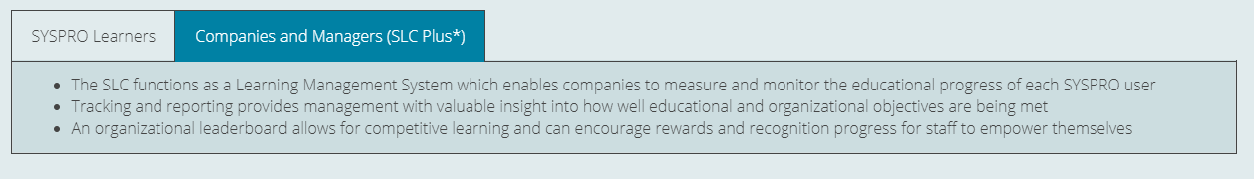

1. **Availability of Application Module Documentation:**

Documentation for application module is not yet available in SYSPRO.

1. **Technical Documentation:**

There is no proper documentation for the technical problems or training but the skilled support team will help resolve any technical problem, giving you a clear and simple solution as fast as we can to minimize interruption.

1. **Cost:**
2. **Cost of ERP Modules:**

**SYSPRO ERP costs** begin at **$199** per user, per month. The more additional **modules** are added, the more expensive the program will be.

1. **Cost of Configuration and Implementation Support:**

Deployment is an additional cost. SYSPRO provides implementation services through its **SYSPRO Reseller Channel** (qualified professionals) and SYSPRO Partners. The cost of this implementation varies based on number of users, system architecture, implementation scope and complexity, company size, industry, and if your company requires any third-party integrations.

1. **Cost of Training:**

There’s nothing mentioned about the cost of training on opting for SYSPRO.

1. **Cost of Maintenance Fees and Software Licenses:**

Ongoing customer support is provided through the SYSPRO Reseller Channel and SYSPRO Partners. In-house support is also available from the vendor to help meet the specific requirements of each customer.  The price of on premise software installation starts at around **$12,000**.

1. **Ability to Integrate Finance and Accounting Module with other ERP Modules**
2. **Integration with Production and Manufacturing Modules:**

The SYSPRO Integration Framework helps us extend our [**ERP applications**](https://www.syspro.com/product/syspro-erp/applications/erp-applications/) to work with other data systems both within and outside of the enterprise.

1. **Integration with Sales and Marketing Modules:**

SYSPRO provides the ability to integrate sales and marketing modules with other ERP modules.

1. **Integration with Human Resources Modules:**

We can integrate Human Resources Module with other ERP modules in SYSPRO.

1. **Integration with web-based Applications:**

Yes, SYSPRO integrates web-based applications with it.

**Workday**

**Introduction :**

Workday is an American cloud-based financial management and human capital management software vendor. Workday was founded by David Duffield, founder and former CEO of ERP company PeopleSoft, and former PeopleSoft chief strategist Aneel Bhusri following Oracle;s hostile takeover of PeopleSoft in 2005. In October 2012, it launched a successful initial public offering that valued the company at $9.5 billion. Competitors include SAP Successfactors, Oracle, Zoho and beqom.

***“I started Workday to bring passion and customer focus back to the business of enterprise applications.”***

***Dave Duffield, Co-founder and Chairman of the Board, Workday***

**1.Corporate History, Experience and Profile :**

* Workday was found in March 2005.
* Launched in November 2006
* In May 2008, Workday signed large contract with Flextronics to provide Human Capital Management software services.
* Suitable for small to medium size companies
* Workday how one can make life simpler.
* 15 Years in business
* More than 10,000 employees

**2.Market Strategy and Strategic Direction :**

**Market Strategy:**

* Of all the companies that are using Workday Human Capital Management, a majority (51%) are large (>$1000M), 25% are small (<$50M) and 19% are medium-sized based on revenue.
* Small business Strategy

**Market Share:**

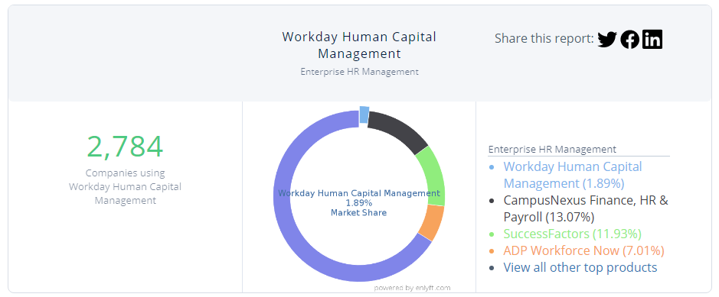

**Market share based on number of employees**

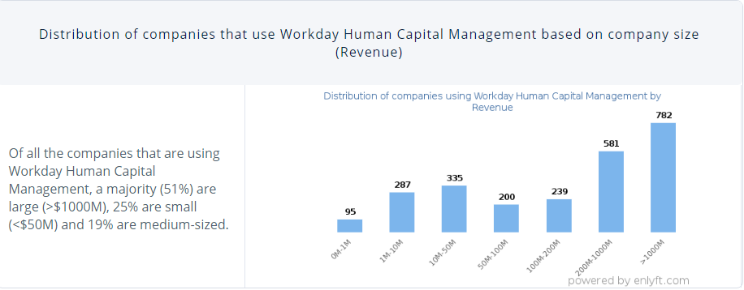

**Features:**

**Actionable Insights**

Using workday will be beneficial for a company as it will get data, analyze the information and take decision in real time. It will eventually provide a real picture off your organization.

**Agility**

Change is good. Workday is good for changing environment. When you evolve, your software will evolve with you.

**Integration**

Workday makes it simple to build, deploy, manage and evolve integrations over time.

**Security**

Your sensitive data is protected by rock-solid physical, network, application, and data-level security.

**Business Assets**

Business assets helps in

* Managing your asset roster, depreciation, and lifecycle accounting
* Defining, tracking, and accounting for both tangible and intangible assets
* Tracking low- and zero-cost items that have high value or liability (e.g., mobile devices or security badges)
* Assigning custody and responsibility of items to workers to prevent cost leakage and security risks due to workers turnover.

**Core Finance**

Core finance helps in

* Accounting and finance
* Management reporting and analysis
* Governance and compliance
* Cash management

**Expense Management**

With workday expense management you can

* Automate your expense management
* Ensure rapid adoption across your global workforce with a consumer
* Gain real time visibility into employee spend with multi-dimensional reporting and analytics
* Real time reporting and analysis
* Fast and efficient settlement

**Grants Management**

Grant management feature provide the following benefits

* Visibility into grant activity
* Efficiency with a unified, fully automated solution
* Improved compliance and control

**Human Resource Management:**

Human resource management helps you to organize, staff and pay your employees.

The further benefits are

* Absence Management
* Compensation Management
* Workforce Lifecycle Management
* Organization Management
* Benefits Administration

**Overall Strengths**

### **Customer Base**

### Workday has large and growing customer base.

### **Cloud based Products**

### Workday has cloud based software products

### **Subscription Contracts**

### Workday has multiple year subscription contracts

### **Ease of Accessibility**

### Workday provides ease of accessibility as it provides access to its products through mobiles.

### **Investments**

### They invest in innovative and research and development projects, which is there major strength.

* **Market Expansion**

They are working for merger and getting acquisitions strengthening offerings.

**Opportunities**

* **Expanding the Product Line**

### Workday has started to expand its product line. It started with HCM and now it has more ventures in ERP like accounting, tracking, recruiting and purchasing. They are also expanding their application’s framework to introduce new features for their customers.

* **Growth in Global CRM and HCM market size**

### HCM market has been rising exponentially due to enhancement in this sector. As we know that real time, factors are in demand and they are giving opportunities to its customers that they can get real time based solutions. The demand of HR solutions are high among large enterprises**.**

* **Customers are migrating to higher end Products**

### Cloud based software and applications are using worldwide as they are very useful and helpful to bring the products to market. Software updates are automatic and multiple users can work on the same resources anywhere. All the crashed or loss data can be recovered easily.

**Key Business Segments**

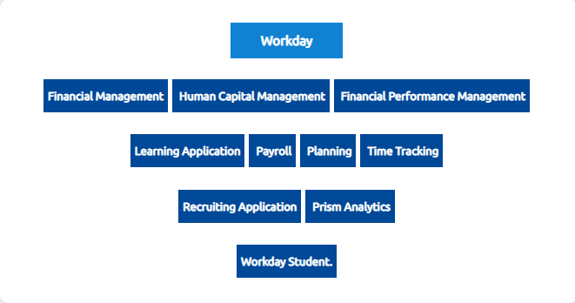

**3.Product Offerings,Integration, and Scalability**

**Workday Applications**

## Financial Management

* **Accounting and Financial Management**

It helps in managing global financial processes easily and efficiently from a single, unified solution.

› Accounting

› Cash management

› Business assets

› Financial reporting

› Controls

* **Revenue Management**

This covers whole contract-to-cash process very efficiently and produce accurate accounting results.

› Contracts and billing

› Revenue recognition

› CRM integration

* **Expenses**

This feature help the workforce to easily capture the expenses on runtime. This helps in capturing and controlling management.

› Mobile Expense Capture

› Expense reports, spend authorizations and freezes

› Multi-currency and VAT support

› Centralized spend controls

* **Grants Management**

Grant management helps you to handle the postaward process for complex grants administration.

› Grant-related expenditures

› Grant activity accounting

› Sponsor reporting

## Human Capital Management

* **Human Resource Management**

This helps enterprises to organize staff and pay their workforce. It further provides

› Organization management

› Compensation management

› Absence management

› Employee self-service

› Manager self-service

* **Payroll**

It addresses the complete needs of enterprise payroll in all over the world in different countries i.e. UK, Canada and USA. It handles specific needs of different enterprises. Payroll comprises of two types.

› Cloud Connect for Third-Party Payroll

› Payroll Co-sourcing Services

**Integration And Scalability:**

Integration platforms helps to build, deploy and maintain data and exchanges.

* **Integration Cloud Platform**

This platform of Workday’s enterprise class Integration Platform-as-a-Service (iPaaS) allows all integrations to deploy to, and run in, the Workday Cloud without on-premise middleware. This platform also enables more real-time interactions between Workday and external applications.

* **Integration Cloud Connect**

Integration Cloud Connect delivers pre-built connections to third-party applications and services.

* **Scalability**

Scalability in Workday is the number of employees a customer has.

* Available computing resources can effortlessly scale up or down according to business requirements.
* Allocate resources to meet customer needs.

**5.Consulting Support :**

* Workday consulting services assist clients with configuring and deploying this program.
* **Support for configuration of Application modules**: Access specific information and documentation that can help you upgrade your workday business.
* **Availability of consulting support**

Support is offered through email and help desks

* Workday HCM consultant provide planning, budgeting and forecasting services
* They also help combining
* HR and financing
* Analytics and planning
* 24 x 7 support service available.
* **Cost of Consulting Support**: Free of cost consulting support provided by workday

**6.Training Availability**

**Training in configuration:**

* Workday Training Courses
* Browse our Web Page and go to the training catalog

### Workday learning hub is providing different level of courses. There are

### Free courses

### Paid courses

### Certifications

### **Technical Training:**

### There are courses available for the technical training.

### **7.Reporting Applications**

### **Types**

### There are three types of reporting in workday

### Basic

### Advanced

### Composite

### **Basic Reporting**

### Its features are very simple, which makes it less useful than the other two types of reporting. At this level of reporting, organizations be able to summarize information related to Time Off, Pay, and more. Organizations are also able to create basic reports as needed or on a recurring basis, and export them to Excel or as a PDF if needed.

### **Advanced Reporting**

Advanced reporting is the feature that will serve the supermajority of organizations reporting needs. This type of reporting will allow people to do fairly complex multi-data object reporting (joins on tables) and allows for complex record selection (filtering) and multi-level sorting.

Some built-in functions exist in Advanced reporting, including totals/subtotals, simple graphing (bar, pie, column), and security on data access that’s automatically applied—which means report developers don’t really have to consider security as it’s built into the system.

**Composite Reporting**

Composite reporting is most often used in edge cases. This type of reporting supports more complex calculations and is used a lot on the Finance side of Workday, but is only occasionally necessary on the HCM side.



**8.User Friendliness**

* Provide information to understand how to implement, manage, and configure Workday.
* Third-party developers can build applications that look like Workday and enable external application data and functionality to be surfaced within Workday.
* Interactive User Interface
* Built in mobile functionality

**Availability of Tutorials:**

### 

### **Availability of Application module Documentation:**

### **Technical Documentation:**

### 

### **Browser Requirements**

### 

**9.Cost**

* Workday costs include implementation costs, licensing costs, and  costs for maintenance and training of key and end users.
* Workday is offering different trainings and the costs for different trainings are different.
* The subscription pricing for the professional license is $100 per user per month.
* The perpetual license and commercial open source license are not provided by Workday.
* Implementation cost is 1.25 times the annual cloud subscription cost

**10.Ability to Integrate:**

**Cloud Integration**

Connecting to other applications and resources should be easy to manage and evolve over time—like Workday web services APIs and the integration cloud. Workday Cloud Platform ‘by expanding the Workday REST API footprint across our applications and technology stack, spanning machine learning, analytics, and conversational interfaces. Additionally, webhooks can now be woven throughout Workday, enabling simple event-driven connections with other applications

**Integration with other Application**

Integration with other modules has been eliminated.

## **Integrating Workday HCM with SumTotal LMS**

Workday is the employee system of record for many enterprises. These companies also have [human capital management platforms](https://www.pixentia.com/services/hcm) from other vendors to handle the unique needs of their businesses.

To enable these platforms to work together, Workday® provides a variety of tools designed to manage the flow of data between them. These include open, standards-based web services, the Workday Integration Cloud Platform, Enterprise Interface Builder (EIB), and Workday Studio, a sophisticated tool for skilled developers.

For the EIB integration, create a custom report in Workday® with the following data:

* employee personal information,
* location,
* manager relationship,
* organization,
* job data, and
* skills and competencies

# **JD Edwards E1 vs SAP Business One vs SYSPRO vs workday:**

JDE E1 wins on Product Offerings, Reporting Applications, User Friendliness and Cost (including consultancy, training and product costs)